26S1 Homework

26S2 Homework
Pronouns and Negative Numbers

What will homework look like?
Every week, we will give you 6–8 questions to work on (about 30 minutes), split between English language arts and mathematics. Some questions will be more challenging than others.

Try your best to submit your work before the start of the next lesson, but remember that homework is optional. You will sometimes see additional practice worksheets. You do not need to complete those; we will only grade the documents labeled “26SX Homework.”

Homework will be graded out of eight points; your assigned tutor will give you feedback on your work. Feel free to resubmit and correct your mistakes as many times as needed.

English Language Arts: Pronouns
- Read the sentence below.
To raise money for uniforms, a car wash will be held by members of the volleyball team.
How should the sentence be revised? [0.5]
- Members of the volleyball team, on Saturday to raise money for uniforms, will hold a car wash.
- To raise money for uniforms, on Saturday a car wash will be held by members of the volleyball team.
- On Saturday to raise money for uniforms, members of the volleyball team will hold a car wash.
- To raise money for uniforms, members of the volleyball team will hold a car wash on Saturday.

- Locate the sentence that should be revised to correct an improper pronoun. [0.5]
(1) The Canadian Indian residential school system was a network of boarding schools for Indigenous children who were removed from their families and culture to be assimilated into Canadian culture. (2) It was funded by the government’s Department of Indian Affairs, in keeping with the Indian Act of 1876, to assimilate Indigenous children into Western culture, and administered by various churches. (3) Over more than a century, about 30 percent of them were placed in residential schools, where at least 6,000 died. (4) The schools themselves were intentionally located far away from home communities, and parental visits were further restricted by a pass system that confined Indigenous peoples to reservations.
Write your answer here.

- Replace the incorrect pronoun(s) in the sentence below with the correct one(s). [1]
The most successful scientists, spanning fields from physics to geology, sees beyond the facts and speculate about their general principles that provide a foundation for new ideas.
Write your answer here.

- Identify and revise the three sentences that have errors in their construction. [2]
(1) Yesterday, my friends and I went to the park after school. (2) Neither John nor Peter remembered to bring their lunch, so my friends and I had to share some of ours. (3) Someone left their backpack on the bench. (4) When the teacher saw my friends and I, she asked us if we had finished our homework, but I had left it at home.
Write your answer here.

Mathematics: Negative Numbers
Clearly indicate the necessary steps, including appropriate formula substitutions, diagrams, graphs, charts, etc. You may not use a calculator. For all questions in this part, a correct numerical answer with no work shown will receive only 0.5 points.

- Evaluate $|\frac{(-3)^{3} - (-4)^{2} + 1}{(-3)(-2)}|$ and reduce the answer to the simplest form. [1]
Write your answer here.

- Two numbers have a sum of $-8$. The absolute value of one number, $6$, is added. What is the other number? [1]
Write your answer here.

- A number and its opposite are multiplied, then $5$ is added. The result is $-4$. What is the absolute value of the number? [1]
Write your answer here.

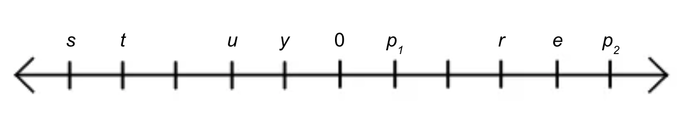
- $s$, $t$, $u$, $y$, $p_{1}$, $r$, $e$, and $p_{2}$ are points on the number line above. If each increment goes by $4$, what is the value of $|s-u|+r$? [1]
Write your answer here.

